Weekly Report 1
Project Phase 4
CS442 : Team-5

New Feature Added :
- Change color touchpad.

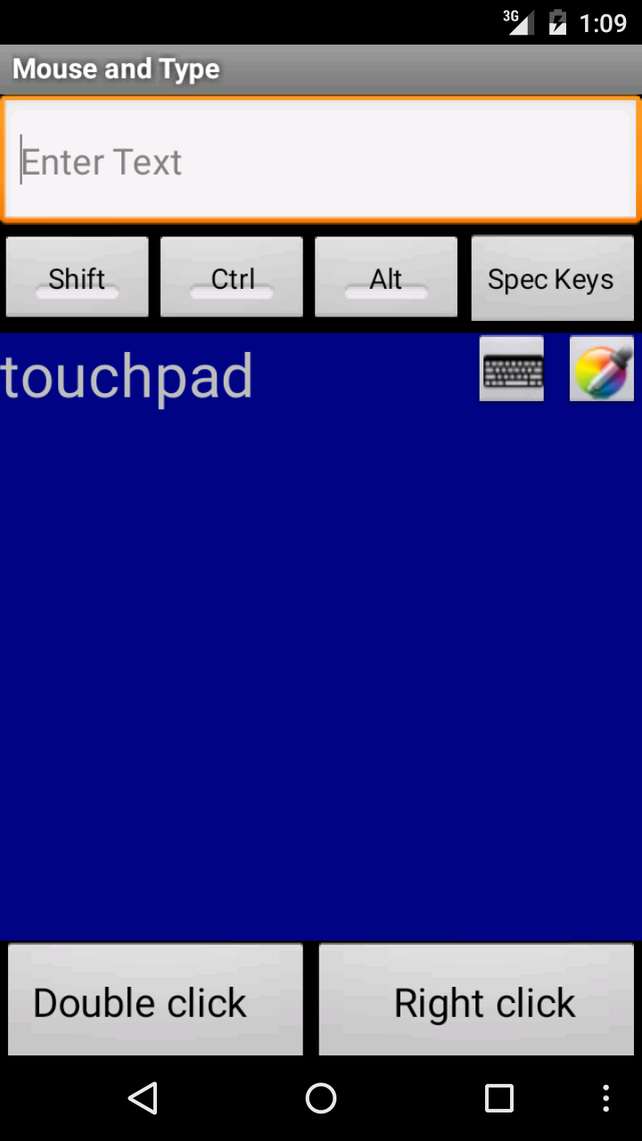

Working Features :
- Control for ppt presentation from android device.

Test for Color change:
-Click on color change button on touchpad :
Expected result: It should change color of touchpad
Test Result : Pass

Status : Creating final report and manual for application.

